|  |  |
| --- | --- |
|  | Unit 3  Semester 1 2019  Mathematics Methods Test 3  **Calculus of Trigonometric Functions, Discrete Random Variables, Bernoulli and Normal Distribution**  **Name** ____________________________    **Total time allowed: 55 minutes. Total marks: 60 marks**  **Section One: Calculator-free**  Time allowed for this section: 30 minutes  Total marks for this section: 30 marks  **Materials allowed for this section:**  SCSA Formula Sheet (provided)  **Instructions to candidates**  Show all of your working clearly. Your working should be in sufficient detail to allow your answers to be checked readily and for marks to be awarded for reasoning. Incorrect answers given without supporting reasoning cannot be allocated any marks. For any question or part question worth more than two marks, valid working or justification is required to receive full marks. If you repeat any question, ensure that you cancel the answer you do not wish to have marked. |

|  |
| --- |
| **Question 1 [2, 2 = 4marks]**  Differentiate the following with respect to x.  (a) $y=\frac{cos2x}{sin 3x}$ (b) y = cos34x |

**Question 2 [2, 3, 3 =8marks]**

Calculate.

1. 
2. b) 
3. 
4. **[2, 2 = 4 marks]**

A couple make a decision to continue having children until the have both a boy and a girl or until they have four children in total. Both boys and girls are equally likely.

1. If the number of children in the family is represented by the random variable X, construct a probability distribution.
2. Calculate the expected number and mostly likely number of children in the family.
3. **[1, 1, 1, 1 = 4 marks]**

If a discrete random variable has an expected value *E(X)* = 15 and a standard deviation of 4, determine:

$E(X-2)$

2. Standard deviation of $(X-2)$
$E(3X+1)$

3. **[2 marks]**

A discrete random variable *X* has the following probability distribution:

|  |  |  |  |  |
| --- | --- | --- | --- | --- |
| *x* | 1 | 2 | 3 | 4 |
| P(X = *x*) | 0.25 | 10*c* -0.1 | 0.25- *c* | 3*c* |

Find the value of the constant *c*.

1. **[1, 2, 2 = 5 marks]**

Each time a certain variety of tomato seed is planted, there is a probability of 0.65 that it will germinate. A scientist plants 20 of the seeds and gives them three days before recording the results.

1. Using the number of seeds which germinate as the discrete random variable, describe this distribution.
2. Without simplifying, state the probability that 15 of the seeds will germinate.
3. The scientist checks after two days and 15 seeds have already germinated. Without simplifying, state the probability that at least 18 will germinate.
4. **[1, 2, = 3 marks]**

The table below describes the probability distribution for a discrete random variable X

|  |  |  |  |  |  |
| --- | --- | --- | --- | --- | --- |
| x | 1 | 2 | 3 | 4 | 5 |
| P(X=x) | 0.1 | p | q | 0.2 | 0.2 |

1. Determine the values for p and q if P(X≤2)=0.25
2. Determine the values of p and q if P(X≥3|X≤4)= $\frac{5}{8}$

**END OF SECTION ONE**

Unit 3

Semester 1 2019

Mathematics Methods Test 3

**. Calculus of Trigonometric Functions, Discrete Random Variables, Bernoulli and Normal Distribution**

**Name** ____________________________

**Total time allowed: 55 minutes. Total marks: 60 marks**

**Section One: Calculator Assumed**

Time allowed for this section: 30 minutes

Total marks for this section: 30 marks

**Materials allowed for this section:**

SCSA Formula Sheet (provided)

1 Page front and back hand written notes

1 Scientific or Graphics calculator

1. **[3 marks]**

Use calculus techniques to calculate the area enclosed between the two curves  and  over the domain  .

1. **[3 marks]**

The probability distribution for X is given by;

$$P\left(X=x\right)= \left\{\begin{matrix}\frac{2x+3}{10k} x=3, 4 \\ \frac{x-1}{10k} x= 5, 6, 7, 8, 9\end{matrix}\right.$$

Find the value(s) of *k*

1. **[4 marks]**

The area of the shaded region of  is 6 units2.

Find an expression to relate the values of *a* and *b*.

***\*\*\*Note: this is a relationship between a and b rather than a numerical solution for the variables\*\*\****

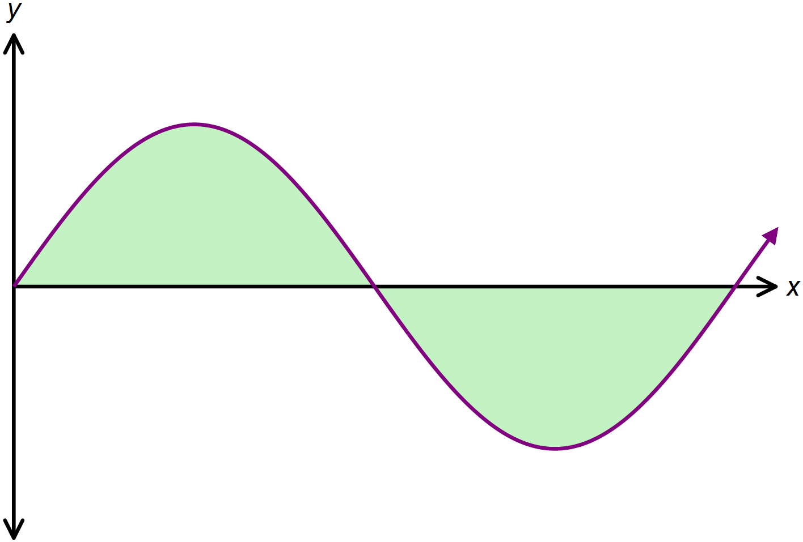

1. **[3, 2 = 5 marks]**

A farmer claims that his bananas are ready to eat 90% of the time.

1. Find the probability that of the next 18 bananas:

(i) at least 14 are ready to eat

(ii) exactly 18 are ready to eat

(iii) between 12 and 15 (inclusive) are ready to eat

b) How many bananas need to be selected to ensure that the probability of having at least one unripe banana is at least 80%?

1. **[1, 1, 1, 2 = 5 marks]**

Given that $X \sim B\left(25, 0.25\right),$ find:

$P(X≥4)$

$P(X<10)$

$P(4≤X<10)$

$P\left(X≥4 | X<10\right)$

1. **[2, 2, 2 - 6 marks]**

The rate of change of pressure acting on an object is modelled by the equation

$\frac{dP}{dt}=4\cos{\frac{πt}{12}}$ where P (kilopascals) is the pressure at time t hours.

1. Find the net change in pressure in the interval 0 ≤ t ≤ 12.
2. Find the net change in pressure in the interval 6 ≤ t ≤ 12.

(c) The net increase in pressure in the interval 0 ≤ t ≤ T is 10 kilopascals. Find T given that T ≤ 24.

1. **[1, 1, 2 = 4 marks]**

Brad designed a new die throwing game. He rolls an unbiased six sided die. If the value on the uppermost face is not a one, he keeps that value as his score for the game. If the value on the uppermost face is a one, he has a second roll and his score for the game is the total obtained from the two rolls.

Let the random variable X represent Brad’s score for the game.

1. Give the possible values of X.
2. Write down the probability distribution for X in the table below.

|  |  |  |  |  |  |  |
| --- | --- | --- | --- | --- | --- | --- |
| **x** |  |  |  |  |  |  |
| **P(X=x)** |  |  |  |  |  |  |

1. Brad decides winning means gaining a score of 6 or 7 and to charge customers $3 to play. He also decides that customers will receive $1 for losing and $5 for winning. Show with the use of calculations whether or not this is a good business model for Brad in the long run.

**END OF SECTION TWO**